**COIS 2020 – Data Structures and Algorithm**

Assignment 3 – File Systems Test Documentation

Submitted By:

Nikhil Pai Ganesh (0595517)

Saalar Faisal (0580714)

1. Root Directory applied:

Root directory “/” added

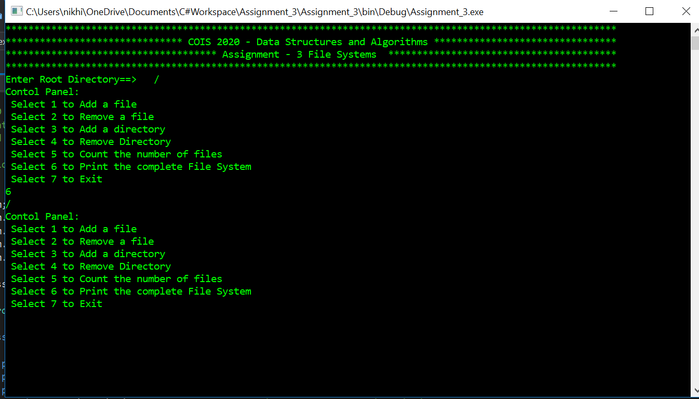

Demonstration:

/

1. Adding Files to the root

Adding File A and File B to the root directory

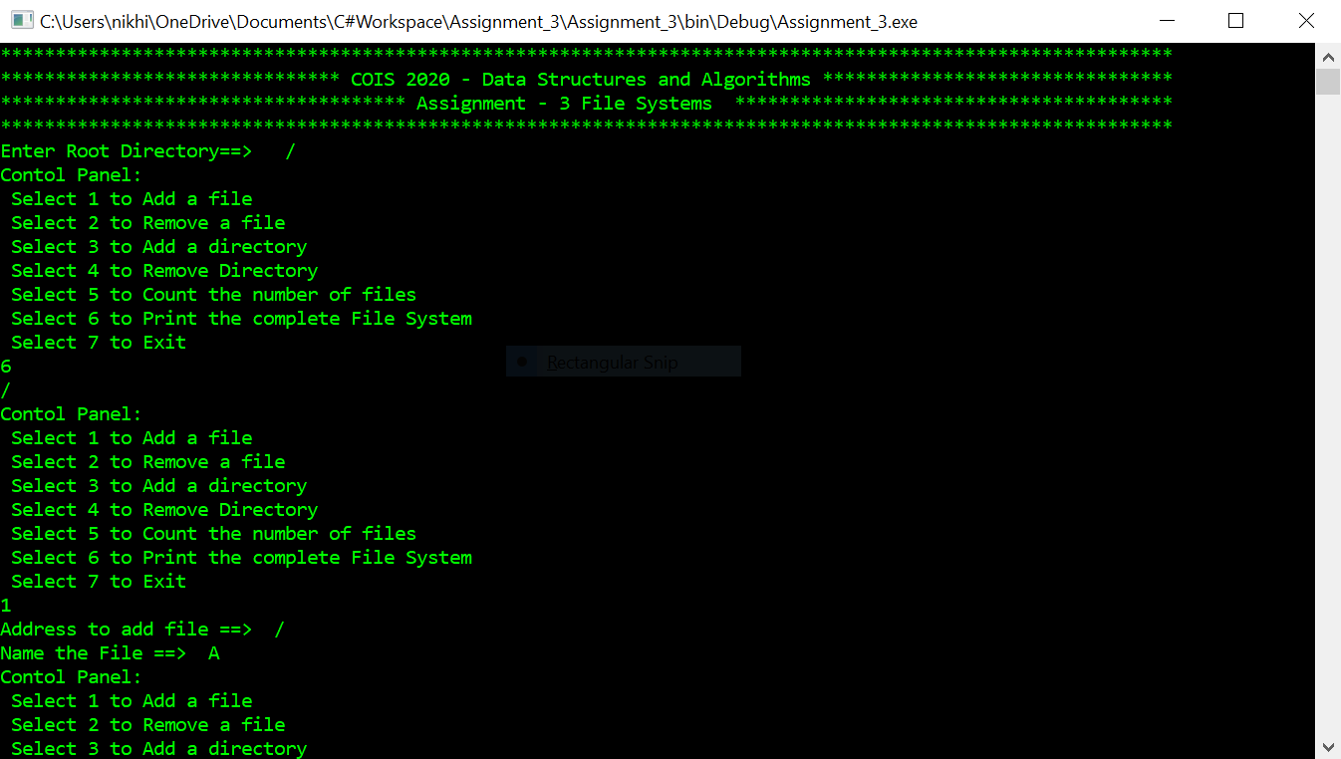

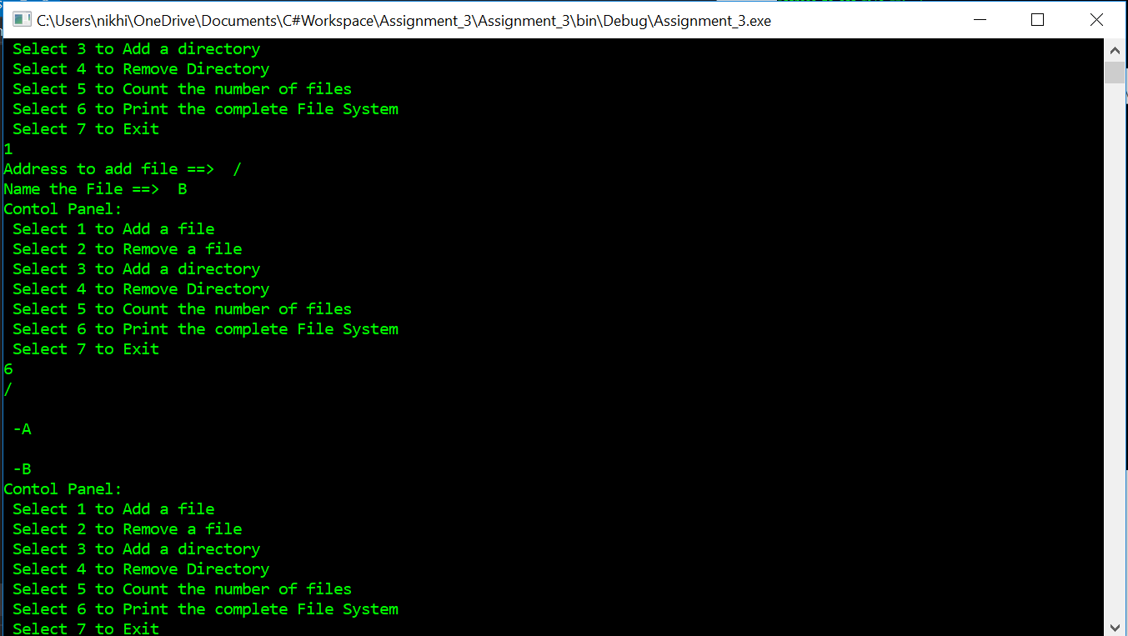

Demonstration:

/

-A -B

1. Adding Directory

Adding directory C to the root “/”, then add directory D to the directory C, then add directory E to directory C.

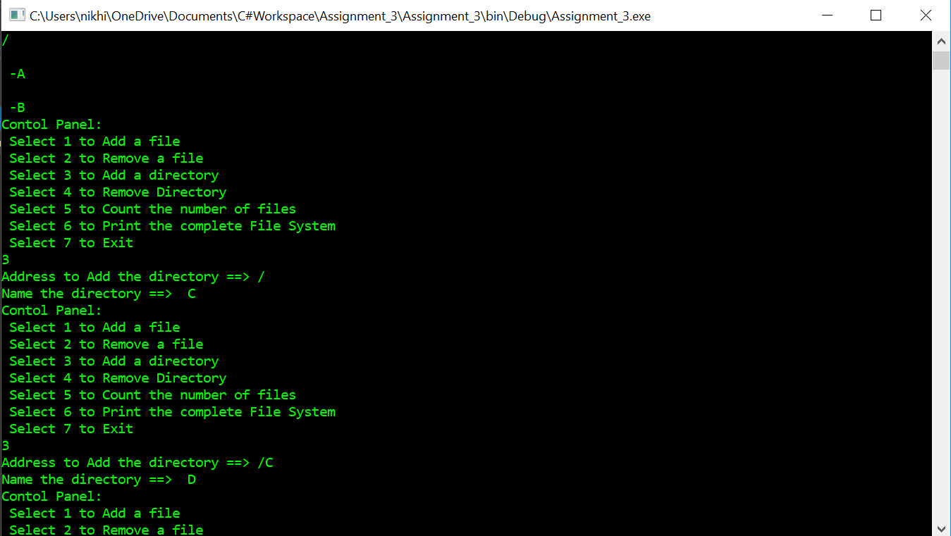

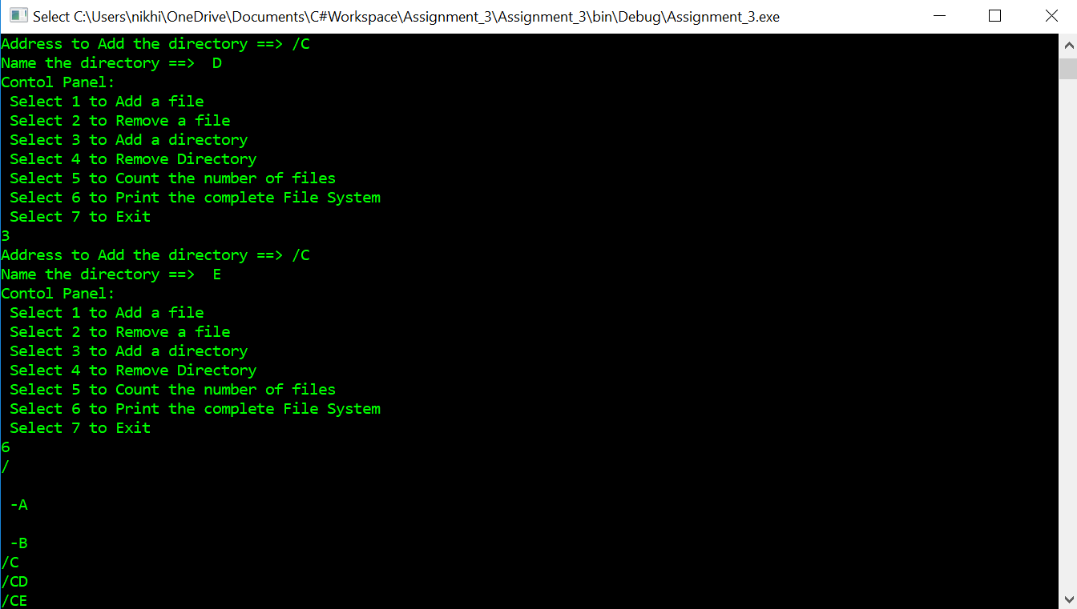

Demonstration:

D

E

C

/

-A -B

-

A

1. Adding files to directories

Adding files F and G in directory C, adding file H in directory E

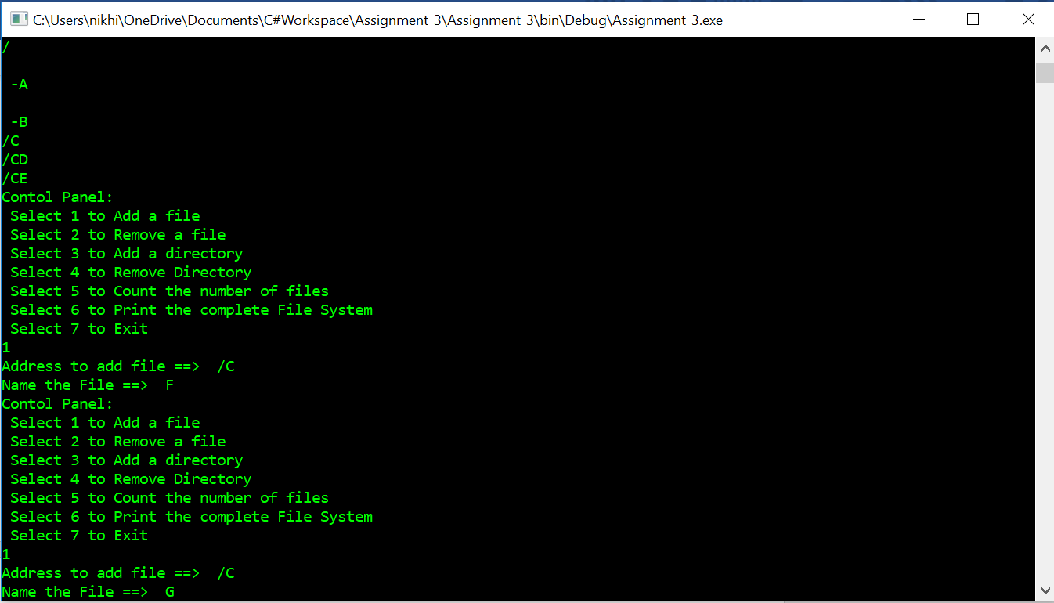

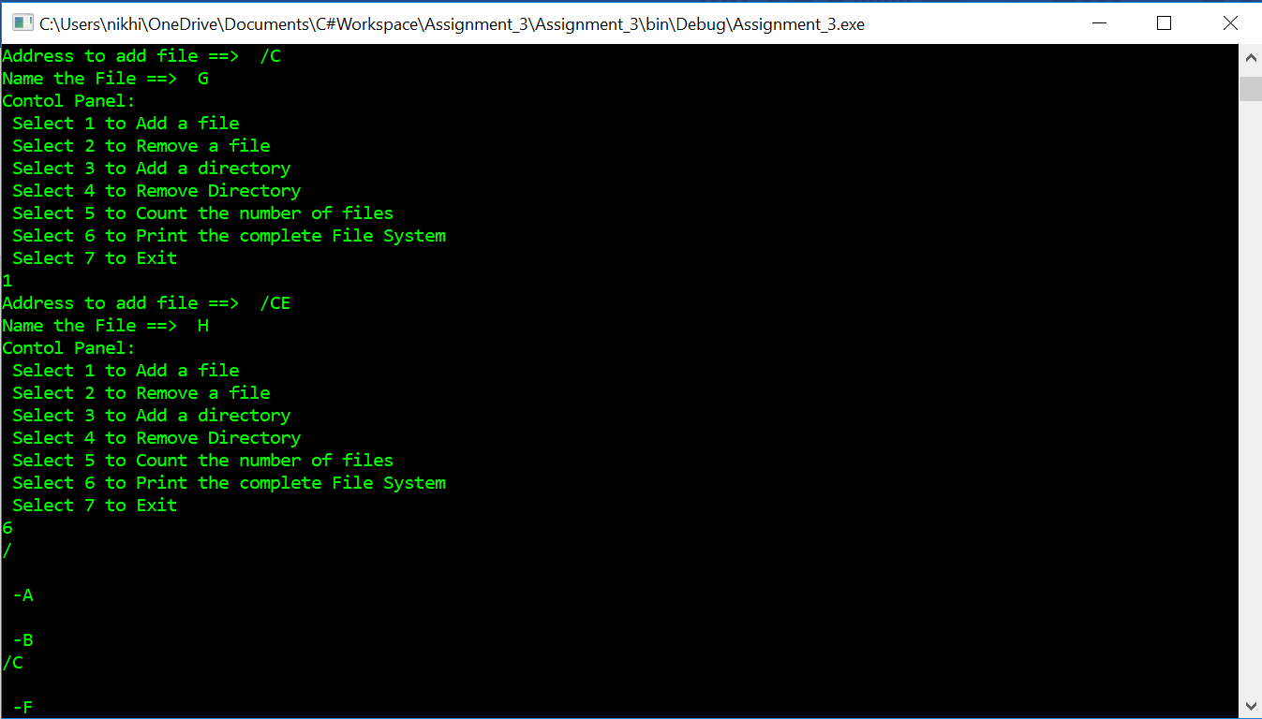

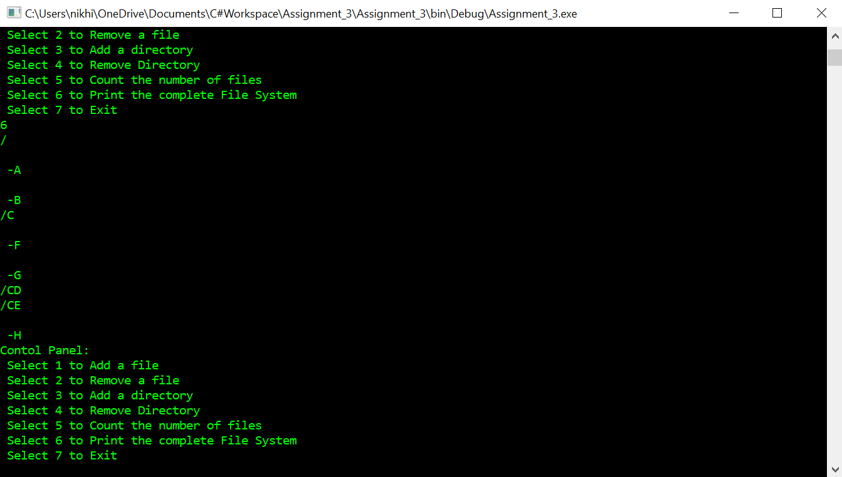

Demonstration:

D

/

-A -B

-

A

E

-H

C

-F -G

1. Adding a directory that already exists

Adding directory C to the root which already exists

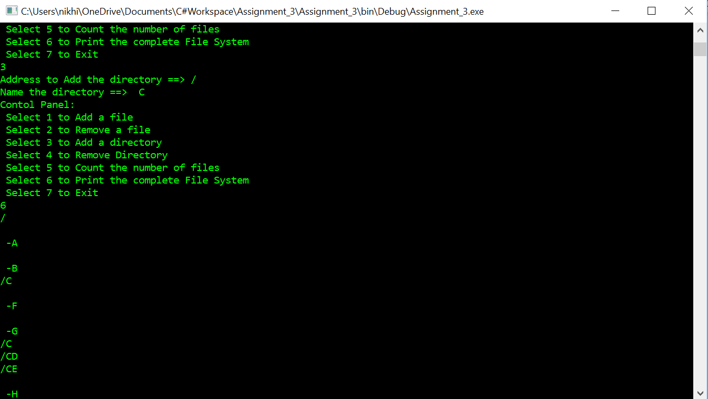

Demonstration:

D

/

-A -B

-

A

C

E

-H

C

-F -G

1. Adding file that already exists

Adding file F to directory C which already exists

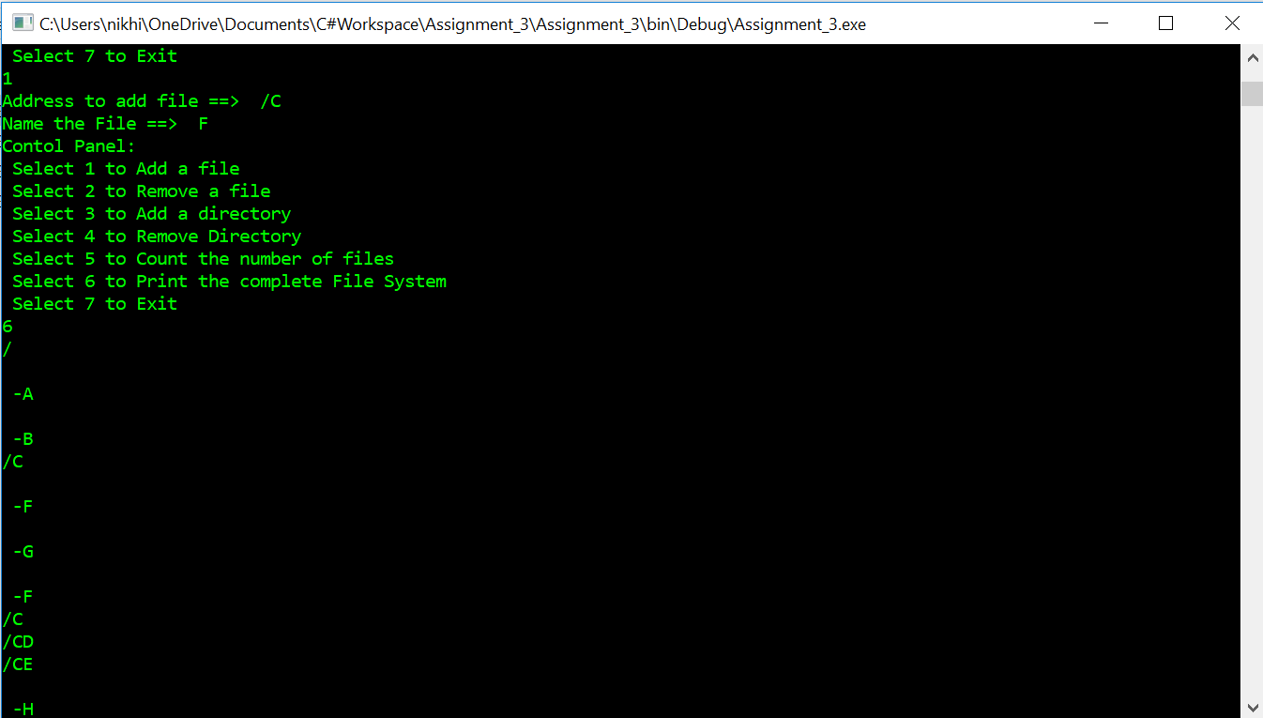

Demonstration:

D

/

-A -B

-

A

C

E

-H

C

-F -G -F

1. Removing a directory

Removing directory D from the file system

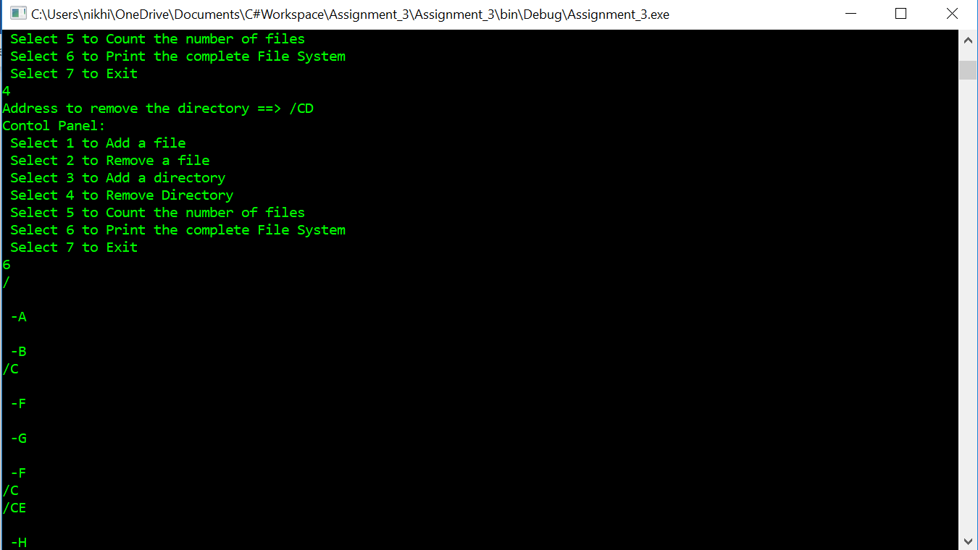

Demonstration:

/

-A -B

-

A

C

E

-H

C

-F -G -F

1. Removing a directory that doesn’t exist

Removing directory D from the file system that no longer exists



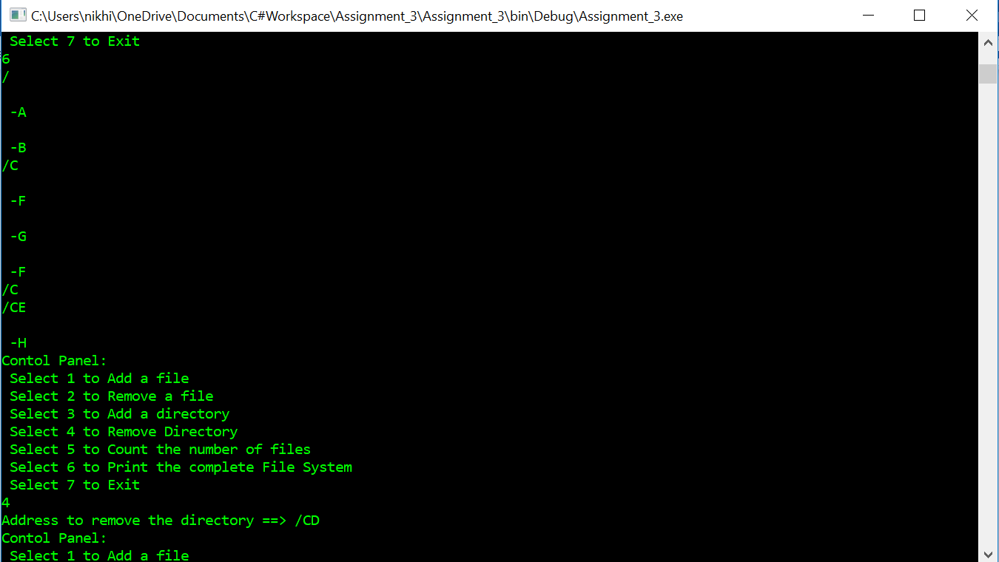

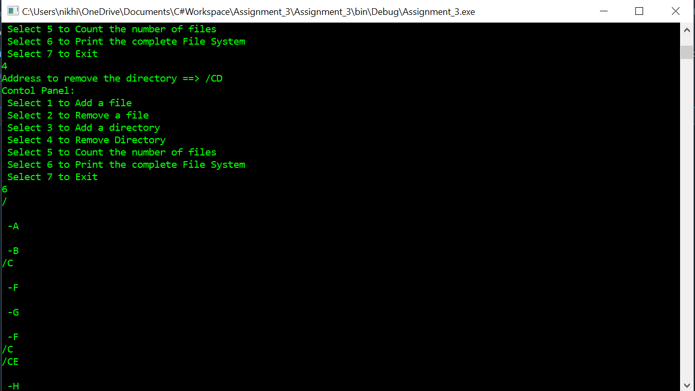

1. Removing a file

Removing file F from directory C

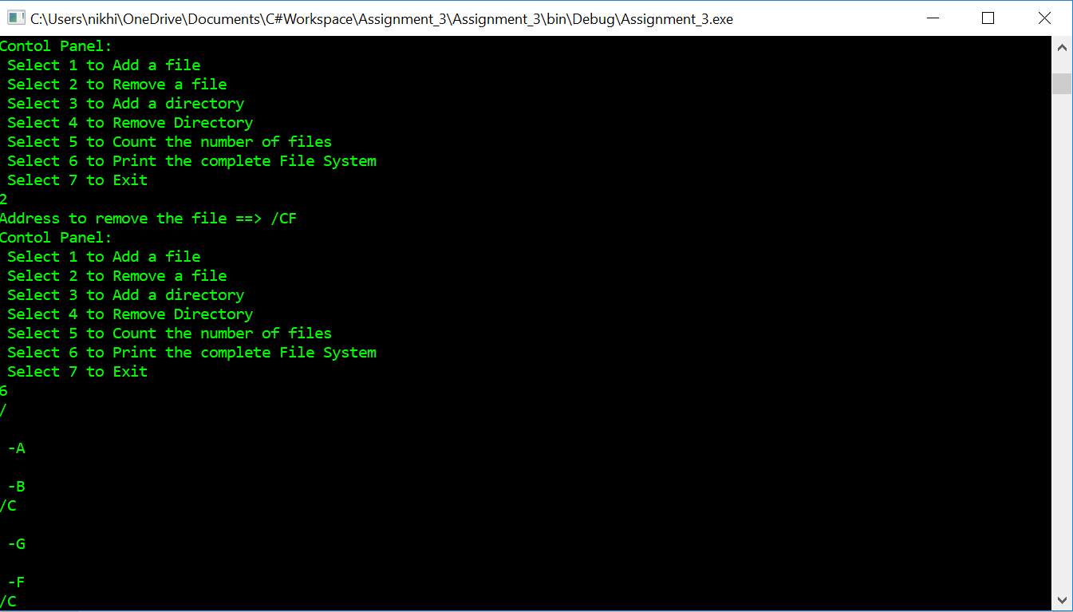

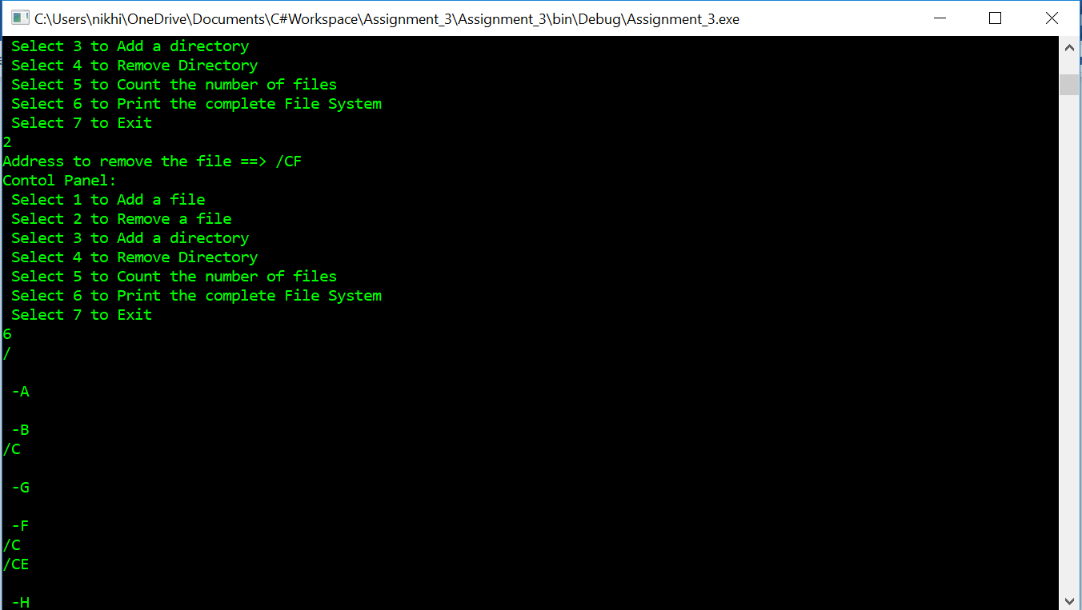

Demonstration:

/

-A -B

-

A

C

E

-H

C

-G -F

1. Removing a file that doesn’t exist

Removing file Y from the file system that doesn’t exist

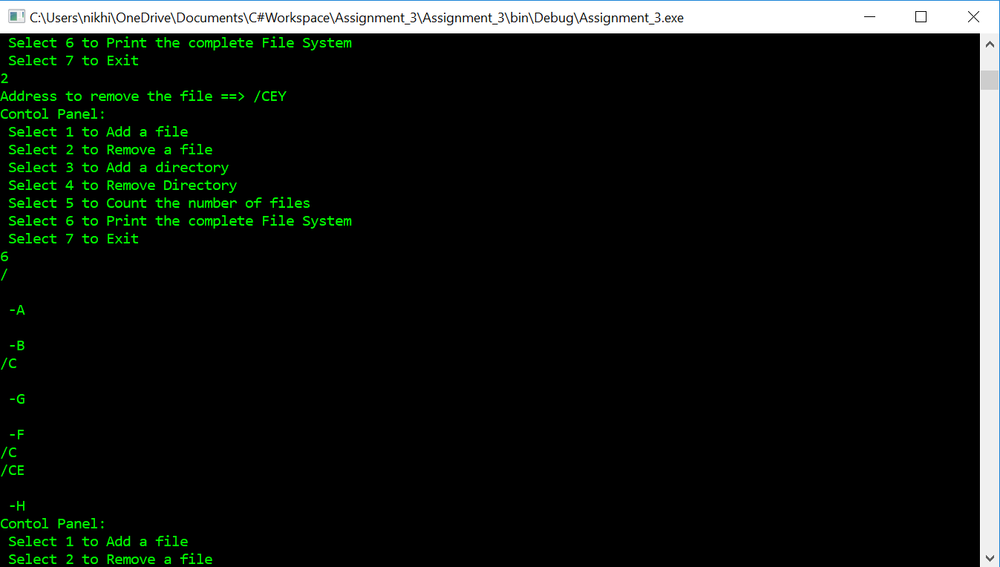

1. Counting the numbers of files in the file system.

This trial is not linked or a continuation of the above trials

Created a new file in the root directory “/” and named it A, then counted the number of files added.

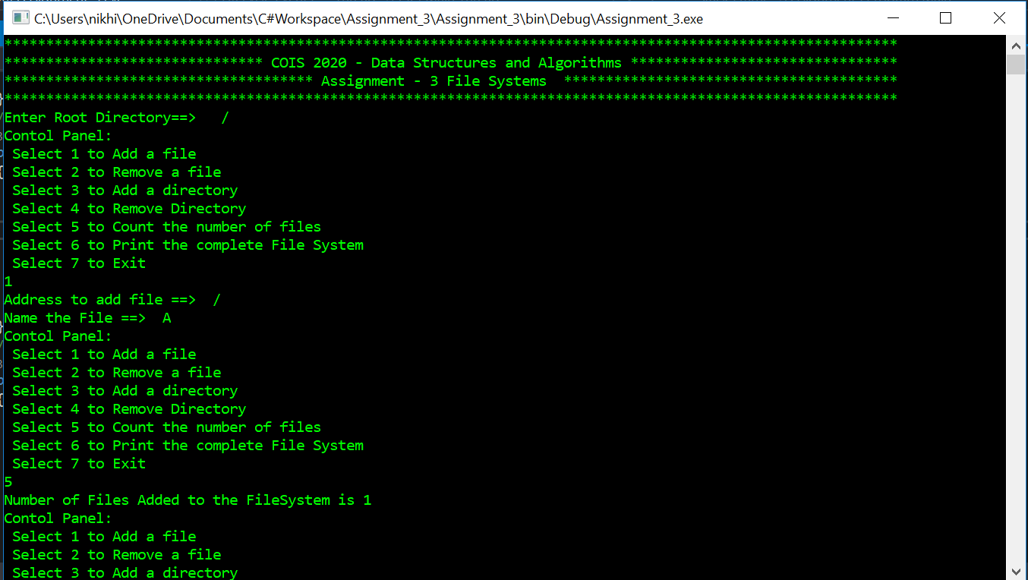

-------------------------------------------x---------------------x-----------------------x-----------------------------------------------